Simplifying more

For the middle case:

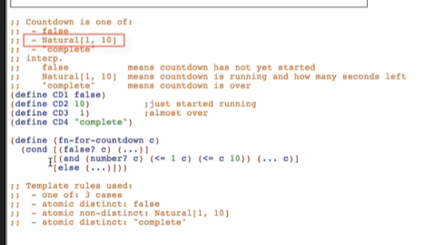



* But because there are only ONE subcategory (is one of) of numbers, we can simplify the 2nd question in the template to (number?

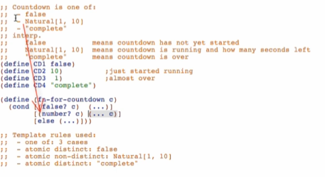

* If it’s a number, then it false into 2nd case already
* This is only valid if there are only ONE subcategory of the given type (eg, string?, Boolean?)

Another example:

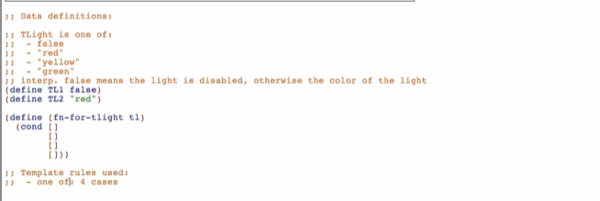

1st case: atomic distinct: false

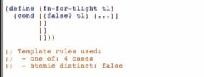

Next 3 cases: atomic distinct: “red”, atomic distinct: “yellow”, atomic distinct: “green”,

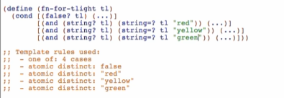

But we can make it simpler since everything after false (Boolean) will be of String type

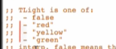

* If all the remaining cases are of the same data types, you don’t need the guard anymore

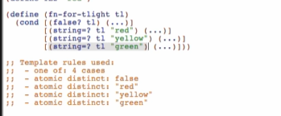

* But it’s not really essential, this is just for simplification

Rules for simplification:

* If a given subclass is the last subclass of its type, we can reduce the test to just the guard
  + Eg. number?, string?, Boolean?
  + 
* If all remaining subclasses are of the same type, we can eliminate all the guards
  + 

Note: always put the guard first before simplification!